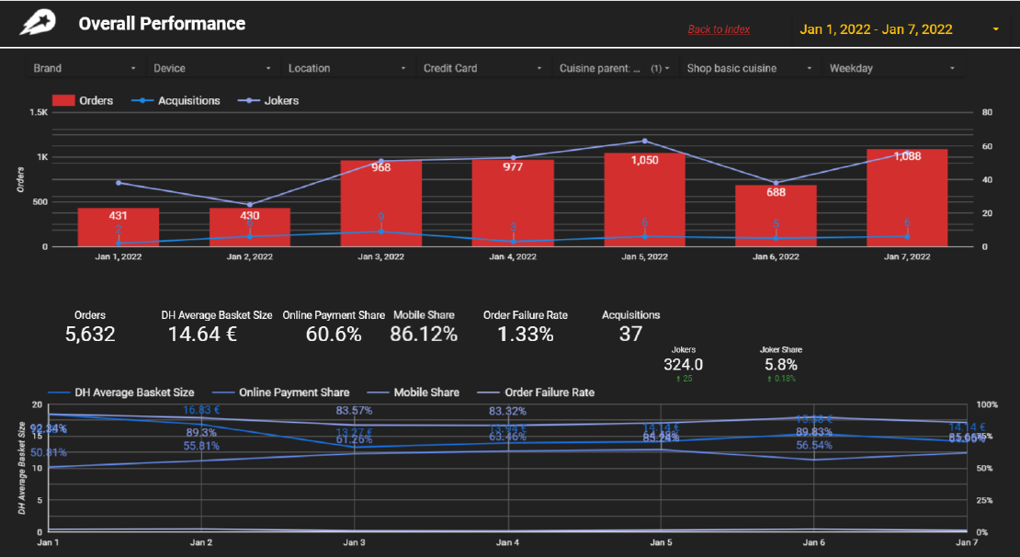

# Cover Slide Comments

I would propose the followings changes on the first graph:

* Removing the “Back to index” and the following ribbon



* Keeping the same number format for y axis, either written as 0.5K, 1k, 2k or 500,1000,2000.
* Acquisitions and Jokers use similar colors and they are not being easily distinguish.
* Changing the gridlines to equal spaces on the first graph

It seems that the jokers are related to the number of order, since they are following the same pattern but the acquisitions do not keep up with either of them , indicating that probably the are not related.

I would propose the following changes on the second graph:

* Labels should not overlap with each other or the axis
* Different colors should be used for easily distinguishing the different lines.

The mobile share seems not be affected by the change of the avg basket size.

The average basket size and number of orders are inversely proportional.

The online payment and the number of orders are proportional.

# Geographic Breakdown

I would propose the following changes:

* Remove the “Back to Index” and the following ribbon





* Remove null values
* Do not use greeklish titles
* Change the structure of the headings and use meaningful heading titles.